Advanced SQL
Exercise 1: Ranking and Window Functions
Query:
create database OnlineRetailStore;

use OnlineRetailStore;

create table Products
(
ProductId INT PRIMARY KEY,
ProductName VARCHAR(50),
Category VARCHAR(50),
Price DECIMAL(10,2)
);

insert into Products
values
(1,'iPhone 15','Electronics',80000),
(2,'Samsung S24','Electronics',75000),
(3,'Laptop','Electronics',75000),
(4,'Headphones','Electronics',10000),

(5,'Nike Shoes','Fashion',12000),
(6,'Adidas Shoes','Fashion',10000),
(7,'Jacket','Fashion',10000),
(8,'T-Shirt','Fashion',2000),

(9,'Refrigerator','Appliances',60000),
(10,'Washing Machine','Appliances',50000),
(11,'Microwave','Appliances',20000);

select * from Products;

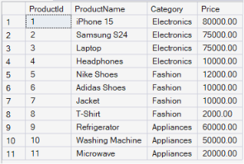

1. ROW_NUMBER()
select ProductName, Category, Price,

ROW_NUMBER()
over(partition by Category order by Price desc)
as RowNumber
from Products;

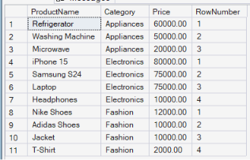

2. RANK()
select ProductName, Category, Price,

RANK()
over(partition by Category order by Price desc)
as ProductRank
from Products;

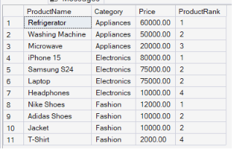
3. DENSE_RANK()
select ProductName, Category, Price,

DENSE_RANK()
over(partition by Category order by Price desc)
as ProductRank
from Products;

